Application Form for JFND Japanese Language & Culture Course
Please attach your recent photo taken within
6 months here
First Semester [July to November, 2018]

(1) Please read the Course Instructions carefully before filling up this Application Form.
(2) Please fill up all the columns in BLOCK CAPITAL. All the columns are mandatory.
(3) Please bring your ID proof while submitting application form.

Did you read the Course Instructions? □ Yes □ No
Name  【In block letters】 | Mr. / Ms. |  |  |  |  |  | Date of birth
Address
Phone/ Mobile |  |  |  |  |  | Email  【In block letters】
Occupation | □ Student □ Teacher [ ]  □ Employed by a Japanese Company  [ ]  □Employed (Company / Government)  □ Self-employed □ Other [ ] |  |  |  |  | Language Ability |  | □English □Hindi □ French  □Japanese □German  □Other [ ]
Which class  would you like to attend?  Please read the  Course Instruction  and choose a  class and tick | Beginner  Pre-  Intermediate | □ Class 1 |  | Wed & Fri |  | 10:30-12:30 |  | Introductory  Conversation L1-10  (For those who have never studied Japanese)
 |  | □ Class 2 |  | Mon & Thu |  | 15:15-17:15
 |  | □ Class 3 |  | Tue & Thu |  | 13:00-15:00 |  | Introductory  Grammar and Script L1-10
 |  | □ Class 4 |  | Wed & Fri |  | 15:15-17:15
 |  | □ Class 5 |  | Wed & Fri |  | 13:00-15:00 |  | ElementaryA2-1  Conversation, Grammar and Script L1-10
 |  | □ Class 6 |  | Tue & Thu |  | 10:30-12:30 |  | ElementaryA2-1  Conversation, Grammar and Script L11-18
 |  | □ Class 7 |  | Tue & Thu |  | 13:00-15:00 |  | ElementaryA2-2  Conversation, Grammar and Script L1-10
 |  | □ Class 8 |  | Tue & Thu |  | 15:15-17:15 |  | ElementaryA2-2  Conversation, Grammar and Script L11-18
 |  | □ Class 9 |  | Wed & Fri |  | 15:15-17:15 |  | Pre-Intermediate A2-B1  Grammar & Script (L 1-10)
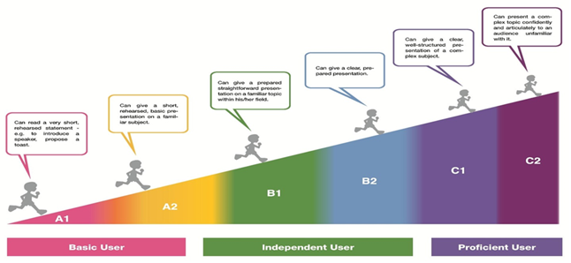
Have you learned Japanese before?  Please fill correct information, if we have seats in upper levels, we will consider applicants with prior experience based on this column. |  |  | □Yes  □ No |  | Name of Institutes :  _______________________________________________________  How long?  [Year ___________ to Year ______ _ ___ ] |  |  |  |  | JLPT Level  (if any):  N______
How do you come to know our course? |  |  | □Website □Email □Poster □Friend  □Other [ ]
Application Submission: 16th (Wed) and 17th (Thu) May, 2018 10:30 – 16:30

Please submit this Application Form at the JNDF Hall (GF) in person.
We will not accept the form otherwise.

1) Please check the box when you agree to the following condition.
□ I understand this course is not for JLPT preparation.
□ I have an availability to continue studying Japanese in the long period
□ I appreciate the teaching method based on notice and discover activities.
□ I will maintain attendance.

2) Describe your motivation for applying to this course.
__________________________________________________________________________________________________________________________________________________________________________________________________________________________________________________________________________________________________________________________________________________________________________________________________________________________________________________________________________________________________________________________________________________________________

3) Why do you choose to study at JFND not in other institutes?
______________________________________________________________________________________________________________________________________________________________________________________________________________________________________________________________________________________________________________________________________________________________________________________________________

4) Are you interested in Japanese Cultural or only Japanese Language?
              - Yes, I am interested in both culture and language.
If yes, what kind of things would you like to learn about Japan?
_________________________________________________________________________________________________________________________________________________________________________________________________________________________________________________________________________________________________________________________
              - No, I am interested in only language.
If no, how would you like to use Japanese?
_________________________________________________________________________________________________________________________________________________________________________________________________________________________________
___________________________________________________________________________

Please submit this Application Form at the JFND Hall (GF) in person.
We will not accept the form otherwise.

Application Submission: 16th (Wed) and 17th (Thu) May, 2018 10:30 – 16:30
For Office Use:
______________________________________________________________________________________________________________________________________________________________________________________________________________________________________________________________________________________________________________________________________________________________________

